Cultural differences

Francois haan

# Version control

| Version | Changes | Date |
| --- | --- | --- |
| 1.0 | 1st version | 23/5/2022 |
| 1.2 | Added reflection and apa style references | 30/5/2022 |

Contents

**Version control** **2**

**Introduction** **4**

Research method **5**

**Wat is ethics within software** **6**

**Cultural** **6**

What is culture? 6

Differences in culture 7

Reflection 9

**Sources** **11**

# 

# Introduction

In this report about ethics I'm going to research some ethical guidelines within software development and working in multicultural groups.

# Research method

desk research with literature study meaning i will be searching the internet for the ethics within software en the usage.

# Wat is ethics within software

Ethics within software has multiple guidelines to follow some coming to order when working within a group and possible cultural differences within the group or for example coding guidelines and not implementing code that could damage or hurt the user in any way. Using your application to contribute to society. be honest and trustworthy about the limitations, potential problems and system capabilities.

Respect other people’s work and copyright, give credit to a creator of ideas, inventions and work, do not claim ownership of work that they or other have shared as a public resource.

Respect privacy of others, this is really important within software because technology enables collection, monitoring and exchange of personal information and often without the knowledge of the affected people, therefore a software engineer should know and understand the rights and responsibilities associated with the collection of personal information. only the minimum amount of personal information should be collected in a system, the retention and disposal periods should be clearly defined and enforced.

Software engineers should insist on and support high quality work from themselves and colleagues, the dignity of stakeholders, users and anyone else affected by the work should be respected throughout the entire process.

Always maintain high standards of professional competence, conduct and ethical practice. Professional competence starts with technical knowledge and social context in which their work will be deployed, it also requires skills in communication, reflective analysis and recognizing and navigating ethical challenges.

Know and respect existing rules within professional work, rules here include local, regional, national, and international laws and regulations also policies and procedures of the organization to which the professional belongs. Accept and provide professional reviews whenever appropriate software engineers should seek and utilize peer and stakeholder reviews and also provide constructed critical reviews of other’s work.

The Code affirms an obligation of computing professionals to use their skills for the benefit of society. (2018, 22 juni). Code of Ethics. Geraadpleegd op 30 mei 2022, van https://www.acm.org/code-of-ethics

# Cultural

## What is culture?

Culture is the characteristics and knowledge of a particular group of people and the associated language, religion, cuisine, social habits and music/art. Cultured is also defined as shared patterns of behavior and interaction, cognitive constructs and understanding this is learned through socialization. Culture can be seen as the growth of a group identity fostered by social patterns unique to the group.

Culture is involved in pretty much everything people do religion, food, what we wear, how we wear it, our language, how we greet people etc, i of course am familiar with the dutch culture but this can also differ very much between the different provinces for example some dutchman are known for being very blunt. I really haven't noticed too much of this characteristic where i live, but in north and south Holland this is much more prevalent.

McKelvie, C., & Pappas, S. (2021, 15 december). What is culture? Livescience.Com. Geraadpleegd op 30 mei 2022, van https://www.livescience.com/21478-what-is-culture-definition-of-culture.html

## Differences in culture

There are a few different metrics about comparing different countries culture wise. involving some characteristics such as: power distance, individualism, masculinity, uncertainty avoidance, long term orientation and indulgence.

**power distance:**

This dimension deals with the fact that all individuals in societies are not equal – it expresses the attitude of the culture towards these inequalities amongst us. Power Distance is defined as the extent to which the less powerful members of institutions and organizations within a country expect and accept that power is distributed unequally.

**Individualism:**

The fundamental issue addressed by this dimension is the degree of interdependence a society maintains among its members. It has to do with whether people´s self-image is defined in terms of “I” or “We”. In Individualist societies people are supposed to look after themselves and their direct family only. In Collectivist societies people belong to ‘in groups’ that take care of them in exchange for loyalty.

**Masculinity:**

A high score (Masculine) on this dimension indicates that the society will be driven by competition, achievement and success, with success being defined by the winner/best in field – a value system that starts in school and continues throughout organizational life.

A low score (Feminine) on the dimension means that the dominant values in society are caring for others and quality of life. A Feminine society is one where quality of life is the sign of success and standing out from the crowd is not admirable. The fundamental issue here is what motivates people, wanting to be the best (Masculine) or liking what you do (Feminine).

**Uncertainty avoidance:**

The dimension Uncertainty Avoidance has to do with the way that a society deals with the fact that the future can never be known: should we try to control the future or just let it happen? This ambiguity brings with it anxiety and different cultures have learnt to deal with this anxiety in different ways. The extent to which the members of a culture feel threatened by ambiguous or unknown situations and have created beliefs and institutions that try to avoid these is reflected in the score on Uncertainty Avoidance.

**Long term orientation:**

This dimension describes how every society has to maintain some links with its own past while dealing with the challenges of the present and future, and societies prioritize these two existential goals differently. Normative societies. which score low on this dimension, for example, prefer to maintain time-honored traditions and norms while viewing societal change with suspicion. Those with a culture which scores high, on the other hand, take a more pragmatic approach: they encourage thrift and efforts in modern education as a way to prepare for the future.

**Indulgence:**

One challenge that confronts humanity, now and in the past, is the degree to which small children are socialized. Without socialization we do not become “human”. This dimension is defined as the extent to which people try to control their desires and impulses, based on the way they were raised. Relatively weak control is called “Indulgence” and relatively strong control is called “Restraint”. Cultures can, therefore, be described as Indulgent or Restrained.

here is a comparison between germany and the netherlands

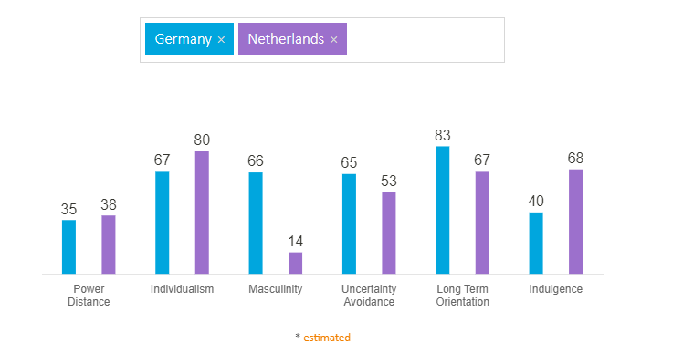

**Power distance**

The difference in power distance is minimal, what the metric means is that there is only a hierarchy for convenience, there’s equal rights, control is disliked and attitude towards managers is informal and on a first name basis.

**Individualism**

In individualism there is a slightly larger gap. What this means is: there is a high preference for a loosely-knit social framework in which individuals are expected to take care of themselves and their immediate families only. The employer/employee relationship is a contract based on mutual advantage, hiring and promotion decisions are supposed to be based on merit only, management is the management of individuals.

**Masculinity**

In masculinity there is a big difference meaning for example in the Netherlands the work/life is more important then in Germany where there is a lot of pride in working. where in the Netherlands people value solidarity, equality and quality in their working lives conflicts are also resolved through compromise and negotiation. in Germany the status is more important through for example cars and watches.

**Uncertainty avoidance**

Here the difference between 2 countries is smaller meaning they are more alike meaning the dutch have a slight preference towards avoiding uncertainty, precision and punctuality are the norm within these countries innovation may be resisted and security is very important.

**Long term orientation**

there is a slightly larger gap between the two however they are still very similar. Both of these are pragmatic countries. In societies with a pragmatic orientation, people believe that truth depends very much on situation, context and time. They show an ability to adapt traditions easily to changed conditions, a strong propensity to save and invest, thriftiness, and perseverance in achieving results.

**Indulgence**

Here there is again a larger gap between the two, The Netherlands have a higher score for indulgence this means in the Netherlands there is higher willingness to indulge to their impulses and desires with regards to enjoying life and having fun. The Netherlands are also more likely to have a positive attitude and be more optimistic. Also the dutch have a higher degree towards free time.

Country Comparison. (2021, 21 juni). Hofstede Insights. Geraadpleegd op 30 mei 2022, van https://www.hofstede-insights.com/country-comparison/germany,the-netherlands/

## Reflection

Within my group there isn’t too much of a culture difference. All of us are native to the Netherlands, of course there are personal differences regarding work ethic etc. Some culture differences I myself have experienced: for example me and my family went to Norway a few years ago, norwegian people tend to be more reserved in social settings and are individual in the day to day. the dutch people we ran into mostly people from holland and the sort are in my experience everything but reserved, at least the people i ran into tended to be really loud and outgoing as opposed to most people i know in limburg, so there’s also a culture difference between the different regions within the Netherlands. but in my opinion most of there cases are some sort of generalization because at the end of the day every person is different regardless of culture.

# Sources

<https://www.acm.org/code-of-ethics>

<https://ethics.acm.org/code-of-ethics/software-engineering-code/>

<https://www.livescience.com/21478-what-is-culture-definition-of-culture.html>

https://www.hofstede-insights.com/country-comparison/